

**TEAM***:* Pentagon

Alexandra Cherry,

Declan Woodham,

Owen Nelson,

Stewart Anderson,

Velislav Velchev

User guide

Version Number: 1.0

Version Date: 18/02/2020

Version History

|  |  |  |  |  |  |
| --- | --- | --- | --- | --- | --- |
| **Version Number** | **Implemented By** | **Revision Date** | **Approved By** | **Approval Date** | **Description of Change** |
| 1.0 | Stewart Anderson |  |  |  | The creation of the whole document |

Table of Contents

2 Introduction 4

2.1 Intended Use 4

2.2 General Information 4

2.3 Description of main functions 4

2.4 Description of the Graphic User Interface 4

3 Navigation 5

3.1 Dashboard 5

3.2 Reports 5

3.3 Plugins 6

3.4 Help 6

4 Instructions 6

4.1 Quick Report 6

4.2 Create a Report 6

4.3 Viewing currently installed plugins 7

4.4 Adding and Removing plugins 8

4.5 Access Plugin Development Guide 9

5 Settings 9

Appendix A: 10

Appendix B: Key Terms 10

Appendix C: Brand Design Specification 10

# 

# Introduction

## Intended Use

This product is intended to be used as a network assessment tool. It should assist a white box penetration test of a network, by helping carry out the information gathering or enumeration stage. At this point (Version 1.0), Network Guardian is not passive, but has no malicious intent.

## General Information

|  |  |
| --- | --- |
| **Software Name** | Network Guardian |
| **Developed by** | Team Pentagon; Alexandra Cherry, Declan Woodham, Owen Nelson, Stewart Anderson, Velislav Velchev |
| **Subject Specialist** | Dr Ethan Bayne |
| **Supported Platforms** | Windows, Linux, Darwin |
| **Release Date** |  |

## Description of main functions

#### Quick Report

This function carries out a report using the standard plugins already installed. These plugins come with Network Guardian, developed to support Windows, Linux and macOS.

#### Create Report

This function allows the user to create a fully custom report, creating a name making it easier to identify, as well as selecting the plugins they wish to execute.

#### View Reports

This function displays the reports that have already been carried out, in a table. This allows the user to sort the table by column, with a search feature allowing the user to quickly look for a report that may have been carried out already.

#### Install Plugins

This allows users to add their own installed plugins as well as remove any of the currently installed plugins if they are not required.

#### View Plugins

This function allows users to view the currently installed plugins in a table, they can be sorted, and plugins can also be searched for, allowing the user to check if a specific plugin is installed. If a plugin is installed, the table can be refreshed to ensure it had successfully installed.

## Description of the Graphic User Interface

The Graphic User Interface (GUI) has a simple easy to follow professional design. The navigation bar is located on the left-hand side of the application, this contains all the pages necessary for the user to work Network Guardian. An easy access ‘Create Report’ button is located at the top right of every page, so a user can always start a new report, there is also a settings icon where the user can change settings, as described in section *5. Settings.*

# Navigation

To navigate through Network Guardian, there is a navigation bar on the left-hand side of the application, as described in section *2.4 Description of the Graphic User Interface.*

## Dashboard

Once the program is run, the software opens and displays the ‘Dashboard’. This shows the ‘Quick Report’ function, the number of reports completed, and the number of plugins currently installed. There is also a table displaying the most recent reports that are completed. To go back to the dashboard, use the navigation bar on the left-hand side, and click ‘Dashboard’.

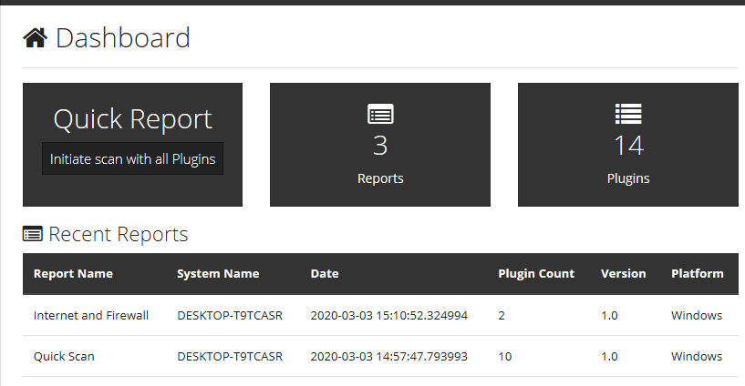

## Reports

To the reports page, click the ‘Reports’ button located in the navigation bar. This will display a table with all the reports that have been carried out, they are found in the ‘reports’ directory. These can be sorted within the table, there is also a search function that can be used to look for a specific kind of report, from ‘Report Name’ to the ‘Platform’ the report was carried out on.

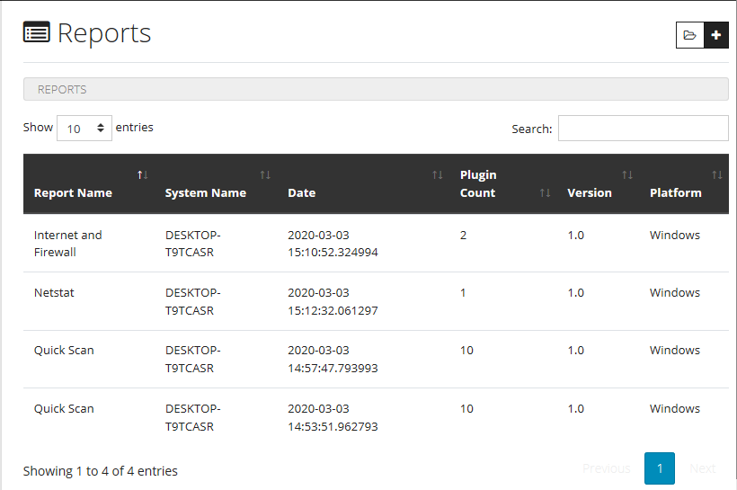

## Plugins

To access the plugins page, click the ‘Plugins’ button located in the navigation bar. This will display a page with a table showing all the currently installed plugins, found in the plugins directory of Network Guardian. These plugins can be sorted within the table, there is also a search function, where specific plugins can be located, whether it searches the ‘Plugin Name’, ‘Author’ or ‘Supported Platform’.

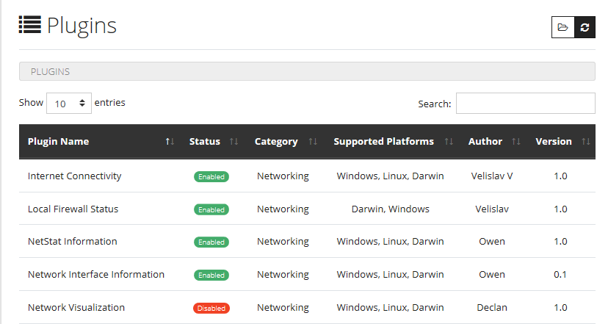

## Help

To access the help page, click the ‘Help’ button located in the navigation bar. This will display an explanation of Network Guardian and the development team. The ‘User Guide’ and ‘Plugin Development Guide’ can also be accessed from this page.

# Instructions

## Quick Report

There is button located on the ‘Dashboard’ page, ‘Initiate scan with all plugins’. Once this is clicked, a report is carried out using all the currently installed plugins.

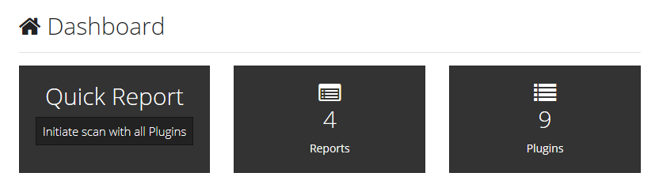

The scanning page is then displayed showing a list of the plugins being ran, as well as a progress bar.

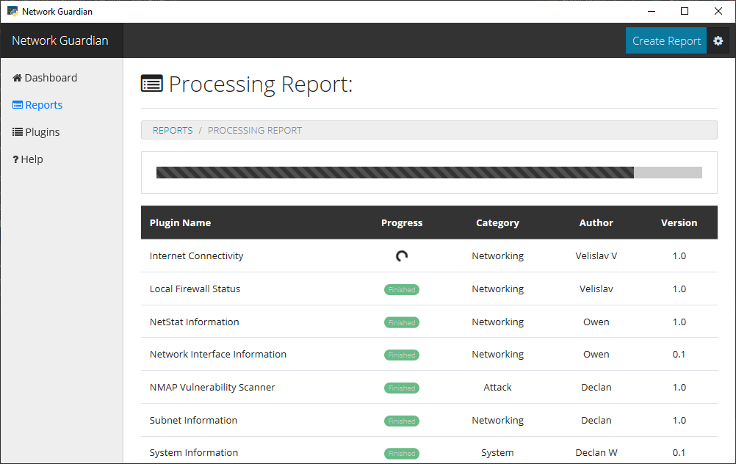

Once the report is completed a results page is then displayed, which shows all the plugins executed. There is also an option to delete the report or export it as an HTML file.

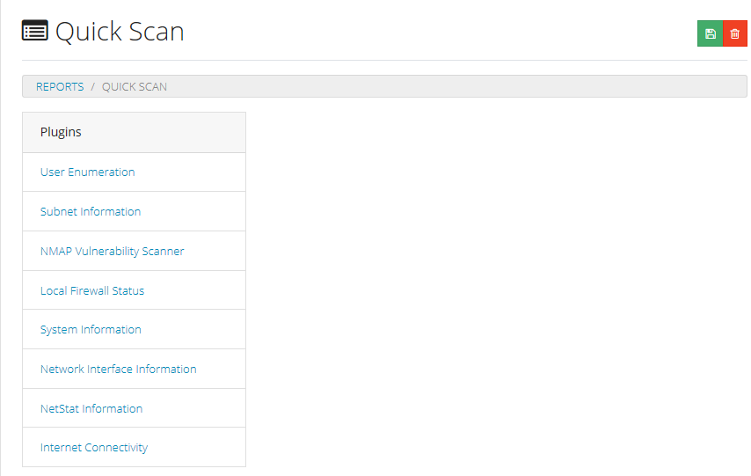

## Create a Report

At the top right of every page there is a ‘Create Report’ button, there is also a button (Plus icon) located on the ‘Reports’ page.





Once this is clicked the user is then taken to a page displaying a form. This form has the following inputs; Name of Report and Plugins. The plugins are a multi-select where the user must select the plugins they wish to execute using *‘ctrl + click’.*

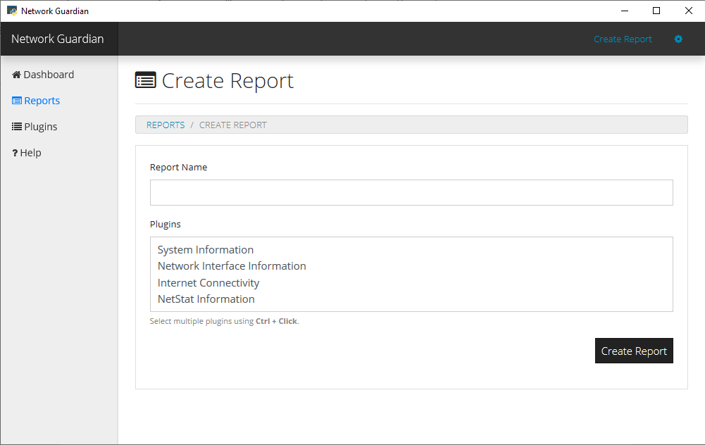

Once the desired plugins are selected the user must then click ‘Create Report’ at the bottom of the form. The user will then be taken to a page showing the progress of the report as well as a table of the selected plugins.



Once the report is completed the results are displayed to the user, these can be viewed again by going to the reports page and selecting the appropriate report.

## Viewing currently installed plugins

To view the currently installed plugins, click ‘Plugins’ located in the navigation bar on the far left. This will take the user to the ‘Plugins’ page.

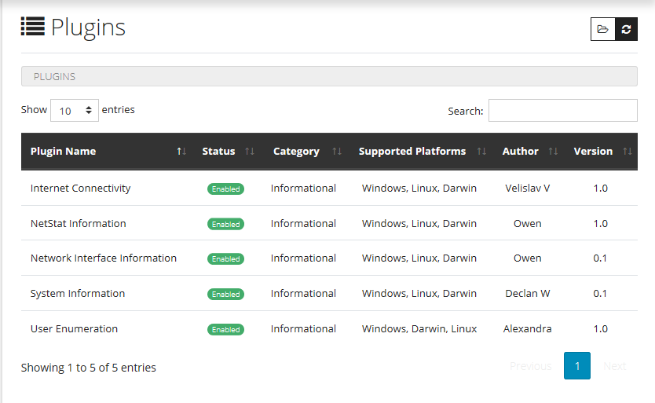

The page displays a table listing all the currently installed plugins and if they are *enabled* and *supported by the current operating system*. The *category* the plugin is in, is also displayed as well as the *author* and *version* of the plugin.

The user can select a plugin and they are taken to a page where more information, for example the description, is displayed to the user.

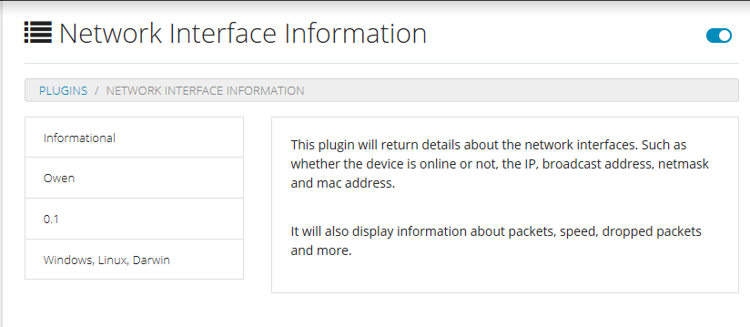

## Adding and Removing plugins

To add or remove a plugin, go to the ‘plugins’ directory for Network Guardian, this can be located by clicking the folder icon on the ‘Plugins’ page.

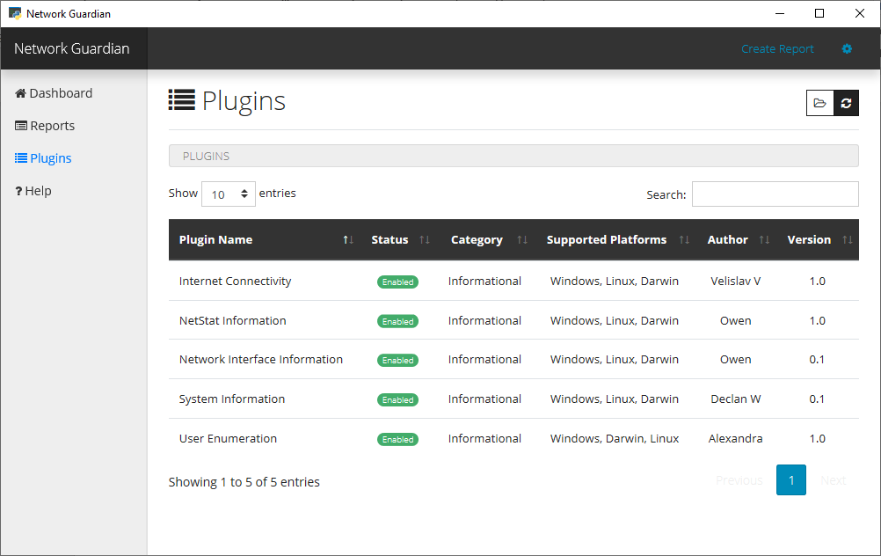

From there the user can add and remove plugins as they wish. To update the table, click the ‘refresh’ icon next to the folder icon and the table will update, displaying the modified plugins and if they are enabled.

## Access Plugin Development Guide

To access the ‘Plugin Development Guide’ go to the ‘Help’ page using the navigation bar. From here select the link with the label ‘Plugin Development Guide’.

# Settings

To access the ‘Settings’ page, click the cog icon at the top right of the page, next to ‘Create Report’.



The settings page allows the user to change the directory for reports as well as plugins. The user can also alter the default name for reports. This is only recommended if you are an advanced user.

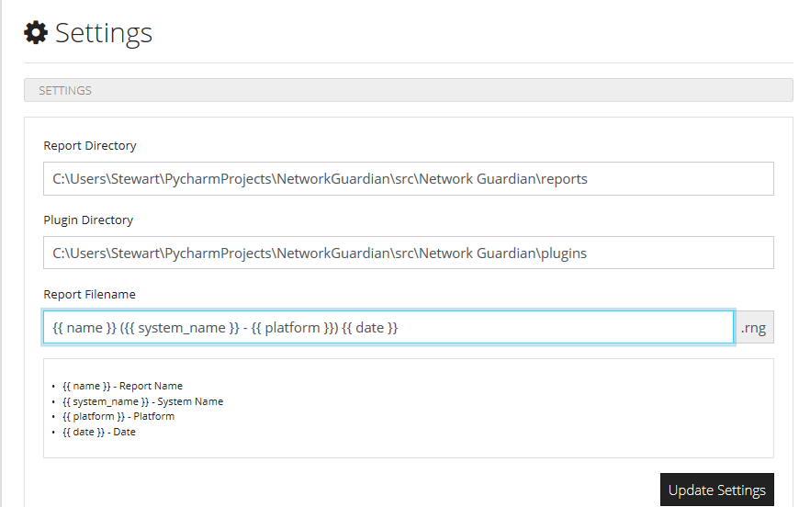

# Appendix A: Standard Plugins

The standard plugins that come with Network Guardian are displayed in the following table:

|  |  |  |  |  |
| --- | --- | --- | --- | --- |
| **Plugin Name** | **Category** | **Supported Platforms** | **Author** | **Version** |
| Internet Connectivity | Networking | Windows, Linux, Darwin | Velislav V. | 1.0 |

This plugin determines whether the local machine has access to the internet. It works by looping through three different URL’s and trying to connect to them and then returning the results back to the user.

|  |  |  |  |  |
| --- | --- | --- | --- | --- |
| **Plugin Name** | **Category** | **Supported Platforms** | **Author** | **Version** |
| Netstat Information | Networking | Windows, Linux, Darwin | Owen N. | 1.0 |

This plugin is based on and uses the psutil (process and system utilities) cross-platform library to retrieve information and store it into variables. The plugin tells you about the different connections and information about them such as the protocol, local address, remote address, status, PID and the program name.

|  |  |  |  |  |
| --- | --- | --- | --- | --- |
| **Plugin Name** | **Category** | **Supported Platforms** | **Author** | **Version** |
| Network Interface Information | Networking | Windows, Linux, Darwin | Owen N. | 1.0 |

This plugin again is based on and uses the psutil (process and system utilities) cross-platform library. It works by gathering information about all the network interfaces and then it puts it to a list which is then passed on to the table which shows things such as whether the device is online or not, the IP, Broadcast Address, netmask, mac address, packets information, speed, dropped packets and more.

|  |  |  |  |  |
| --- | --- | --- | --- | --- |
| **Plugin Name** | **Category** | **Supported Platforms** | **Author** | **Version** |
| System Information | System | Windows, Linux, Darwin | Declan W. | 1.0 |

This plugin returns information about the device it has been run on such as the system name, username, the platform of the device, operating system, processor and memory size and it formats it in a user-friendly format using a table.

|  |  |  |  |  |
| --- | --- | --- | --- | --- |
| **Plugin Name** | **Category** | **Supported Platforms** | **Author** | **Version** |
| User Enumeration | Enumeration | Windows, Linux, Darwin | Alexandra C. | 1.0 |

This plugin uses the grp module that provides access to the Unix group Database. It is a Unix specific service, so all the methods of this module are available on Unix versions only.

|  |  |  |  |  |
| --- | --- | --- | --- | --- |
| **Plugin Name** | **Category** | **Supported Platforms** | **Author** | **Version** |
| Local Firewall Status | Enumeration | Windows, Darwin | Velislav V. | 1.0 |

This plugin uses the grp module that provides access to the Unix group Database. It is a Unix specific service, so all the methods of this module are available on Unix versions only.

# Appendix B: Key Terms

# Appendix C: Brand Design Specification

Acceptable Logo’s:

|  |  |  |
| --- | --- | --- |
|  |  |  |
| Logo | Text Logo | Icon |

Heading Fonts: Segoe UI Semibold

Paragraph Fonts: Segoe UI

Font Size: 10px – 14px